8. Obtener el total de películas

SELECT COUNT(*) AS total_peliculas FROM film;

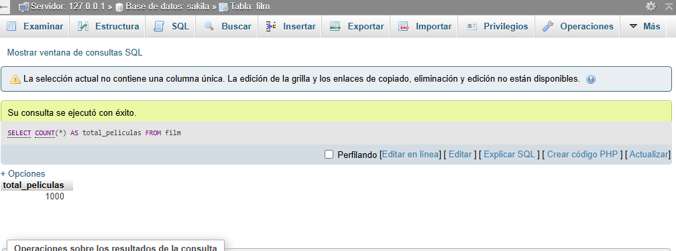

9. Obtener listado de actores y la cantidad de películas

SELECT

a.actor_id,

CONCAT(a.first_name, ' ', a.last_name) AS nombre_actor,

COUNT(fa.film_id) AS cantidad_peliculas

FROM

actor a

JOIN

film_actor fa ON a.actor_id = fa.actor_id

GROUP BY

a.actor_id;

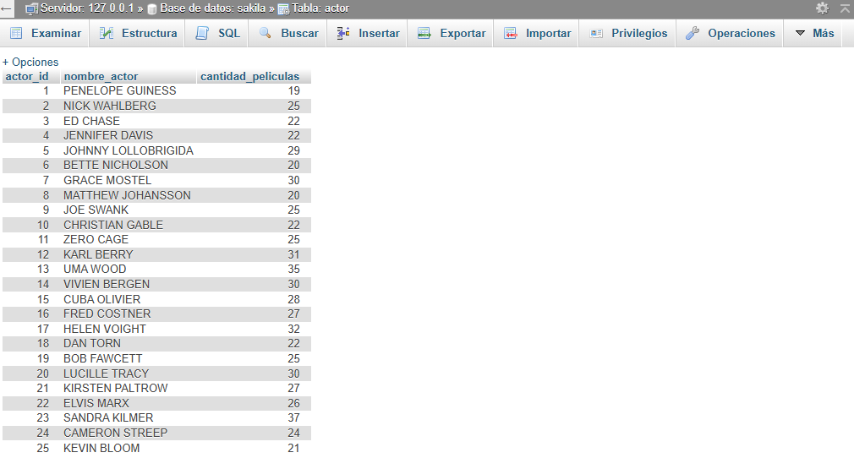

10. Obtener listado de ingresos por tienda

SELECT

s.store_id,

SUM(p.amount) AS ingresos_totales

FROM

payment p

JOIN

staff st ON p.staff_id = st.staff_id

JOIN

store s ON st.store_id = s.store_id

GROUP BY

s.store_id;

